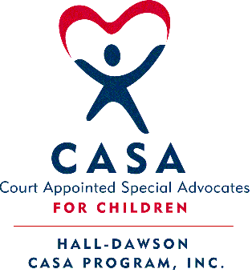
Hall-Dawson CASA Program 2019 In-Service Schedule
CASA Volunteers and Staff are required 12 hours of annual In-Service Training
Dawson In-Service on Tuesdays & Hall In-Service on Thursdays

January 8, 2019 @ 12:00 pm – Location: Dawsonville Goodwill: NOA: No One Alone
- A crisis center and shelter for victims of domestic violence, serving Dawson and Lumpkin counties.
January 31, 2019 @ 12:00 pm - The Little House: CANCELLED

February 14, 2019 @ 9:30 am - Atlanta Capitol: CASA Day at the Capitol
- Annual CASA Day at the Capitol. Meet us at the Park-and-Ride lot at 7:30am on Exit 4 of I-985 in Buford, GA.
March 28, 2019 @ 12:00 pm – The Little House: The Northern Star Transitional ILP: Susan Lancaster.
  - A new Transitional Independent Living Program in Dahlonega, GA for youth transitioning to adulthood.
April 9, 2019 @ 6:00pm – Location: Gainesville’s First Presbyterian Church: Volunteer Appreciation Banquet
- Join us for our annual volunteer appreciation banquet.
April 16, 2019 @ 12:00 pm – Location: Dawsonville Goodwill: Stewards of Children Training (2-Hour Class)
- Learn how to prevent, recognize, and react responsibly to child sexual abuse. Free for Dawson CASAs & Residents.
May 31 – June 4, 2019 @ Hyatt Regency in Atlanta, GA: National CASA Conference
- A powerful conference, packed with guest speakers from across the nation to improve CASA advocacy.
June 27, 2019 @ 12:00 pm – The Little House: Avita’s Yellow Ribbon Program
- A Suicide Prevention Program to help spread awareness on preventing suicide in teens and how to help in a crisis.
July 16, 2019 @ ___:___ am/pm – Location: Dawsonville Goodwill:

July 25, 2019 @ 5:30 pm – The Little House: Educational Advocacy – Christie Ledlow-Hodges, CASA Supervisor
- Increase your knowledge and skills regarding advocating for your CASA youth’s education.
August 3, 2019 @ ___:___ am – Atlanta, GA: Georgia CASA Conference at Renaissance Waverly Hotel & Convention Center
- 20+ workshops offered by experts in the field, annual awards, keynote address, & networking opportunities. Registration opens online at www.gacasa.org/conference and Hall-Dawson CASA will reimburse half the cost upon request.
September 26, 2019 @ 12:00 pm – The Little House: Mediation Training – Susan Rigdon, CASA Supervisor/Staff Attorney
- Learn about CASA’s role and responsibilities when Juvenile Court cases are referred to mediation.
October 8, 2019 @ ___:___ am/pm – Location: Dawsonville Goodwill:

October 31, 2019 @ 12:00 pm – The Little House: Fetal Alcohol and Substance Exposure – Dr. Karen Kuehn Howell, Emory
- Learn about the effects of alcohol and illegal substances on the fetus and its effect on child development.
November 21, 2019 @ 5:30 pm – The Little House:

December 12, 2019 @ 2:00 pm - 4:00 pm AND 5:30 pm - 7:30 pm; The Little House "Open House and Toy Drive"
- CASA Volunteers come pick out Christmas Gifts to deliver to their CASA Children. Wrapping station with supplies will be available to make the gifts festive! Light refreshments provided. Bring your best Christmas cheer =)

