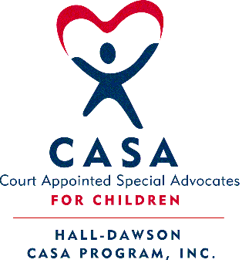
Hall-Dawson CASA Program 2018 Peer Group Schedule
CASA Volunteers and Staff are required 12 hours of annual In-Service Training

January 25, 2018 @ 12:00 pm - The Little House: Kate’s Club Resource – Lane Pease, MS NCC
- Learn about free recreational and therapeutic group programs, education, and advocacy for grieving youth ages 5-18.

February 14, 2018 @ 9:30am - Atlanta Capitol: CASA Day at the Capitol
- Annual CASA Day at the Capitol. Meet us at the Park-and-Ride lot at 7:30am on Exit 4 of I-985 in Buford, GA.

March 10th - 13th, 2018 – Boston, MA: National CASA Conference
- Boston Sheraton Hotel. Registration opened Nov. 2017 on their website: http://conference.casaforchildren.org/

March 29, 2018 MANDATORY @ 12:00pm – The Little House: Advanced Topics in Advocacy (Repeat Session from Oct2017)
  - In-depth review of the Role of a CASA; Confidentiality; Grant reporting; Courtroom Etiquette; Reengagement.

*Independent In-service Opportunity: Movie Critique of “The Florida Project” (See Heather’s email)*

April 26, 2018 @ 6:00pm – Location: Gainesville’s First Presbyterian Church: Volunteer Appreciation Banquet
- Join us for our annual Volunteer Appreciation Banquet and enjoy a nice dinner with your peers.

May 31, 2018 @ 12:00 pm – The Little House: Legacy Link’s “Kinship Care” Grandparent Support Group – Julia Jessee
- Learn about our local monthly support group meetings for grandparents raising their grandchildren.

June 28, 2018 @ 5:30 pm – The Little House: Avita’s “Evolve” Emerging Adult Program – Jenna Parmer
- Evolve targets at risk youth aged 16+ with mental health needs to provide services and support before adulthood.

July 26, 2018 @ 1:30 pm to 5:00 pm – The Little House: Trauma 101 Workshop –GSU Child Welfare Training Collaborative
- In this 3.5-hour course, you will gain an understanding of the impact of trauma on children.

August 4, 2018 @ 8:30 am – Atlanta, GA: Georgia CASA Conference at Renaissance Waverly Hotel & Convention Center
- 20+ workshops offered by experts in the field, annual awards, keynote address, & networking opportunities. Registration opens online at www.gacasa.org/conference and Hall-Dawson CASA will reimburse half the cost upon request.

September 27, 2018 @ 1:30pm to 5pm – The Little House: Brain 101 Workshop –GSU Child Welfare Training Collaborative
- In this 3.5-hour course, you will gain an understanding of the impact of trauma on brain development.

October 25, 2018 @ _:__ am/pm – The Little House:

November 29, 2018 @ _:__ am/pm – The Little House:

December 13, 2018 @ 2:00 pm - 4:00 pm AND 6:00 pm - 8:00 pm; The Little House "Open House and Toy Drive"
- CASA Volunteers come pick out Christmas Gifts to deliver to their CASA Children. Wrapping station with supplies will be available to make the gifts festive! Light refreshments provided. Bring your best Christmas cheer =)

