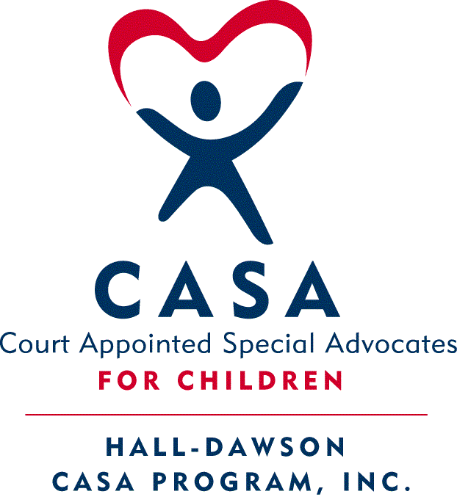
Hall-Dawson CASA Program, Inc.

In-Person Child Visits
Safety Precaution and Guidance During COVID-19

In an effort to minimize the spread of COVID-19 and for the health and safety of the children we serve, their families and caregivers, and assigned CASA Volunteers, the following guidelines are required for in-person child visits. To support continuation of required monthly visits between CASA Volunteers and children, temporary guidance was issued by National CASA to allow for alternatives to in-person visits. Hall-Dawson CASA and Georgia CASA encourage the continuation of these alternative methods through June 30, 2020. It is also strongly suggested to conduct more frequent communications with the child and caregivers while in-person visits are not occurring.

We have begun receiving requests to resume in-person visits between the child and CASA Volunteer. Making decisions about this will be handled on a case-by-case basis and we must take into consideration the health and risk to the child, all household members, and the Volunteer. Older adults and people with underlying medical conditions are at higher risk for developing complications from a COVID-19 infection and should take maximum precautions against exposure. In the event that the child(ren), caregivers, DFCS, CASA Volunteer, and CASA staff all agree, in-person visits may resume under the following conditions:

- CASA staff will ask if the Volunteer has/has had a fever, cough, sore throat, shortness of breath or other symptoms of a respiratory infection and has not had contact with a person with a confirmed or suspected case of COVID-19 illness.

- The CASA staff or Volunteer shall secure written permission from the DFCS case manager or supervisor. Email is sufficient.

- Once written permission is received from DFCS, the CASA Volunteer may schedule an in-person visit with caregiver. However, if the caregiver is not comfortable with an in-person visits, the CASA Volunteer will continue with virtual contact.

- Immediately before the visit, the CASA Volunteer shall call to confirm that everyone in the home continues to be free from symptoms associated with COVID-19. In-person visits must be postponed if any person in the child’s placement has a fever, cough, sore throat, shortness of breath or other symptoms of a respiratory infection or has been exposed to a person with a confirmed or suspected case of COVID-19 illness.

- During an in-person visit, the CASA Volunteer and any participating CASA staff must observe the following recommended CDC social distancing guidelines:

  - Avoid close contact.
    - Remember that some people without symptoms may be able to spread virus.
    - Stay at least 6 feet (about 2 arms’ length) from others.
    - Do not gather in groups and avoid crowded places. Seek comfortable outdoors spaces, when possible.

  - Cover mouth and nose with a cloth face cover when around others.
    - COVID-19 can be spread to others even if one does not feel sick.
    - The cloth face cover is meant to protect others in case the wearer is infected.
    - Continue to keep 6 feet between individuals. The cloth face cover is not a substitute for social distancing.

  - Wash hands often.
    - Wash hands with soap and water for at least 20 seconds before and after visit.
    - If soap and water are not readily available, use a hand sanitizer that contains at least 70% alcohol.
    - Avoid touching eyes, nose and mouth with unwashed hands.

If the caregiver has concerns or requests special conditions, the CASA Volunteer should make every effort to respect his or her preferences. If the child is in a group home or child caring institution, confirm with the provider to determine any additional requirements or restrictions in addition to those stated above.

By following these guidelines, Hall-Dawson CASA will continue to meet our shared commitment to the safety, health, and well-being of children in foster care, their families, and their caregivers.

If a CASA Volunteer is unable to follow the above instructions, virtual visits should continue until all public health and CDC guidelines have expired.

